DofE MALE Participant Kit Request for ………………………………………………………….
Clothing Type | Size | Preferred name on clothing
Outdoor Coat
Hoodie* or Fleece* (*delete as appropriate)
T-Shirt

Please use tables below for guidance on sizing as kit cannot be returned once embroidered.

Note: The Fleece/Hoodie and T-Shirt will belong to you. Outdoor coats will not and are to be returned to the Unit on completion of your award.

Outdoor Jacket Size Guide
T-Shirt, Hoodies or Fleece Size Guide
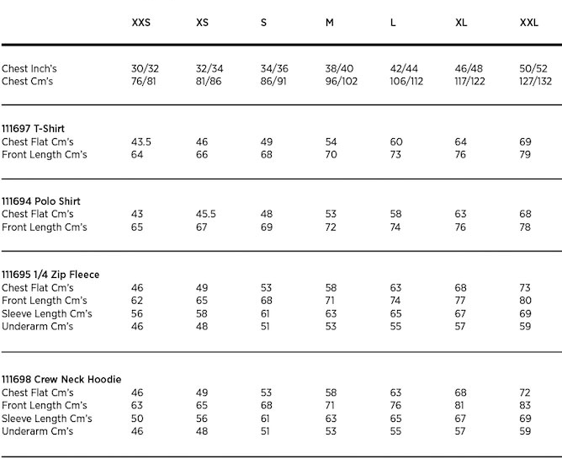
DofE FEMALE Participant Kit Request for ………………………………………………………….
Clothing Type | Size | Preferred name on clothing
Outdoor Coat
Hoodie* or Fleece* (*delete as appropriate)
T-Shirt

Please use tables below for guidance on sizing as kit cannot be returned once embroidered.

Note: The Fleece/Hoodie and T-Shirt will belong to you. Outdoor coats will not and are to be returned to the Unit on completion of your award.

Outdoor Jacket Size Guide
T-Shirt, Hoodies or Fleece Size Guide

